Computer Language Coding Concepts

Active Clauses in a Command Reference in a Diagram
Active clauses in a command reference have been conceptually explained in the article Active Clauses in a Command Reference.

This article only illustrates how active clauses in a command reference look in a diagram.

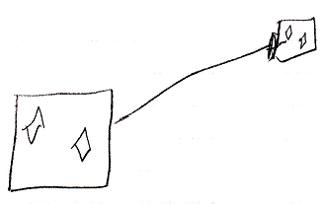

The large square on the left is a command reference. It is pointing out its target command definition with an object line, the solid line, targeting the square on the right, which is the command definition. The command reference on the left contains two active clauses, diamonds, that do not redirect their target. The target definition on the right also shows the diamonds inside of it. Both command reference and target definition both represent the same command object, so their contents are also the same, so they both show active clauses.

The creation behavior of active clauses in a command reference will not be further explained with diagrams in this article. Refer to the article Creation Behavior of Command Callls in a Diagram for an illustration of how the creation behavior of command calls looks in a diagram.

See also: Active Clauses in a Command Reference,
Creation Behavior of Command Calls in a Diagram

Author & Copyright: Jan-Joost van Zon Date: August 9, 2008 – August 9, 2008 Location: Oosterhout, The Netherlands Status: Finished

